
Foundation University Islamabad
School of Science and Technology

Name: Hunaina Yasir Roll Number: 073
Subject: Oop Lab Section: B
LAB NO. 8

Task1. Student and Employee Record System
Create a C++ program using hybrid inheritance to manage a system where a person can be both a student and an employee (e.g., an intern).
• Base class: Person (attributes: name, age)
• Derived classes: Student (attribute: rollNo), Employee (attribute: employeeId)
• Final class: StudentIntern (inherits from both Student and Employee) Implement functions to input and display data from each class.
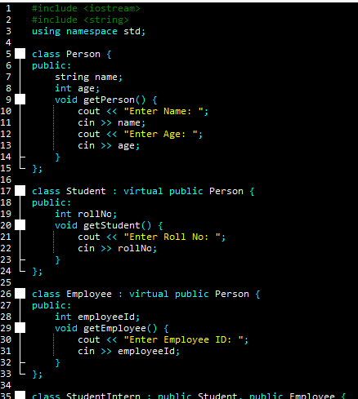
SOURCE CODE:
#include <iostream>
#include <string>
using namespace std;

class Person {
public:
string name;
int age;
void getPerson() {
cout << "Enter Name: ";
cin >> name;
cout << "Enter Age: ";
cin >> age;
}
};

class Student : virtual public Person {
public:
int rollNo;
void getStudent() {
cout << "Enter Roll No: ";
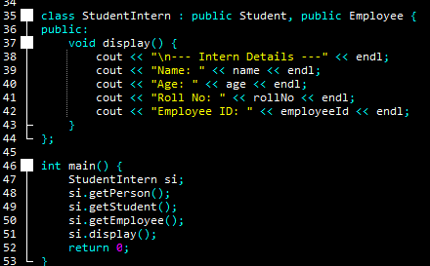
cin >> rollNo;
}
};

class Employee : virtual public Person {
public:
int employeeId;
void getEmployee() {
cout << "Enter Employee ID: ";
cin >> employeeId;
}
};

class StudentIntern : public Student, public Employee {
public:
void display() {
cout << "\n--- Intern Details ---" << endl;
cout << "Name: " << name << endl;
cout << "Age: " << age << endl;
cout << "Roll No: " << rollNo << endl;
cout << "Employee ID: " << employeeId << endl;
}
};

int main() {
StudentIntern si;
si.getPerson();
si.getStudent();
si.getEmployee();
si.display();
return 0;
}

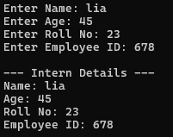
OUTPUT:
Enter Name: lia
Enter Age: 45
Enter Roll No: 23
Enter Employee ID: 678

--- Intern Details ---
Name: lia
Age: 45
Roll No: 23
Employee ID: 678
Task2. School Management System
Design a program to represent a school management system using hybrid inheritance. • Base class: School (attribute: schoolName)
• Derived class 1: Teacher (attribute: subject)
• Derived class 2: Student (attribute: grade)
• Derived class from both Teacher and Student: TeachingAssistant Display information for all entities.
SOURCE CODE:
#include <iostream>
#include <string>
using namespace std;

class School {
public:
string schoolName;
void getSchool() {
cout << "Enter School Name: ";
cin >> schoolName;
}
};

class Teacher : virtual public School {
public:
string subject;
void getTeacher() {
cout << "Enter Subject: ";
cin >> subject;
}
};

class Student : virtual public School {
public:
string grade;
void getStudent() {
cout << "Enter Grade: ";
cin >> grade;
}
};

class TeachingAssistant : public Teacher, public Student {
public:
void show() {
cout << "\n--- TA Info ---" << endl;
cout << "School: " << schoolName << endl;
cout << "Subject: " << subject << endl;
cout << "Grade: " << grade << endl;
}
};

int main() {
TeachingAssistant ta;
ta.getSchool();
ta.getTeacher();
ta.getStudent();
ta.show();
return 0;
}
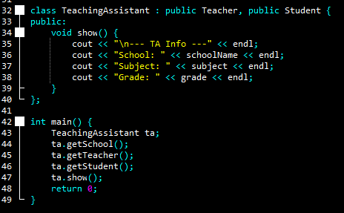
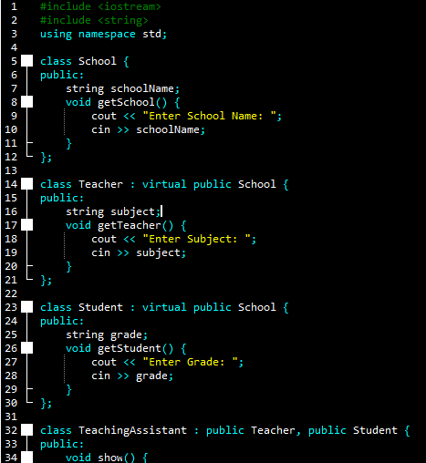

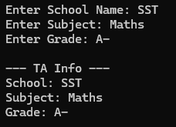
OUTPUT:
Enter School Name: SST
Enter Subject: Maths
Enter Grade: A-

--- TA Info ---
School: SST
Subject: Maths
Grade: A-

Task3. Vehicle Management System
Implement a system to manage different types of vehicles using hybrid inheritance.
• Base class: Vehicle (attribute: vehicleType)
• Derived class 1: Car
• Derived class 2: Bike
• From Car, derive ElectricCar
• From Bike, derive ElectricBike Each class should override a method to display specific features.
SOURCE CODE:
#include <iostream>
#include <string>
using namespace std;

class Vehicle {
public:
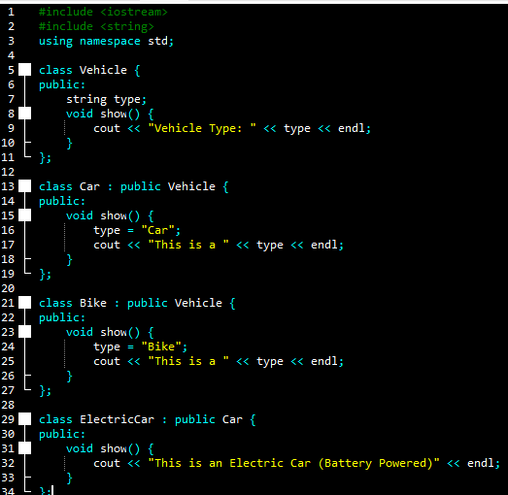
string type;
void show() {
cout << "Vehicle Type: " << type << endl;
}
};

class Car : public Vehicle {
public:
void show() {
type = "Car";
cout << "This is a " << type << endl;
}
};

class Bike : public Vehicle {
public:
void show() {
type = "Bike";
cout << "This is a " << type << endl;
}
};

class ElectricCar : public Car {
public:
void show() {
cout << "This is an Electric Car (Battery Powered)" << endl;
}
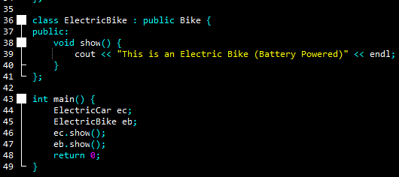
};

class ElectricBike : public Bike {
public:
void show() {
cout << "This is an Electric Bike (Battery Powered)" << endl;
}
};

int main() {
ElectricCar ec;
ElectricBike eb;
ec.show();
eb.show();
return 0;
}

OUTPUT:
This is an Electric Car (Battery Powered)
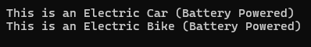
This is an Electric Bike (Battery Powered)

Task4. Food Menu System
Create a food menu program using hybrid inheritance.
• Base class: Meal
• Derived classes: Breakfast, Lunch, and Dessert (inherit from Meal)
• From Breakfast, derive Juice, and from Dessert, derive Cake Each class should display a custom message using the print() function.
SOURCE CODE:
#include <iostream>
using namespace std;

class Meal {
public:
void print() {
cout << "This is a Meal." << endl;
}
};

class Breakfast : public Meal {
public:
void print() {
cout << "Breakfast is the first meal." << endl;
}
};

class Lunch : public Meal {
public:
void print() {
cout << "Lunch is the midday meal." << endl;
}
};

class Dessert : public Meal {
public:
void print() {
cout << "Dessert is something sweet." << endl;
}
};

class Juice : public Breakfast {
public:
void print() {
cout << "Juice is a fresh breakfast drink." << endl;
}
};

class Cake : public Dessert {
public:
void print() {
cout << "Cake is a yummy dessert." << endl;
}
};

int main() {
Juice j;
Cake c;
Lunch l;

j.print();
l.print();
c.print();

return 0;
}

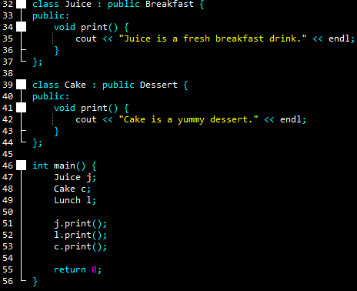
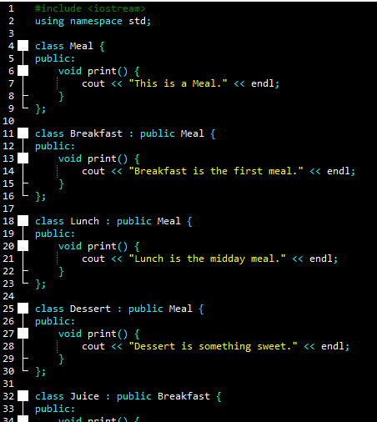
OUTPUT:
Juice is a fresh breakfast drink.
Lunch is the midday meal.
Cake is a yummy dessert.
